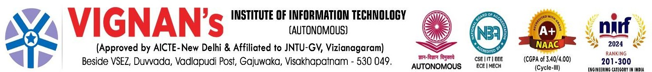



MONTHLY REPORT

**May 2025**

Submitted to



JNTU-GV University

GURAJADA VIZIANAGARAM. DWARAPUDI, VIZIANAGARAM,

ANDHRA PRADESH - 535 003



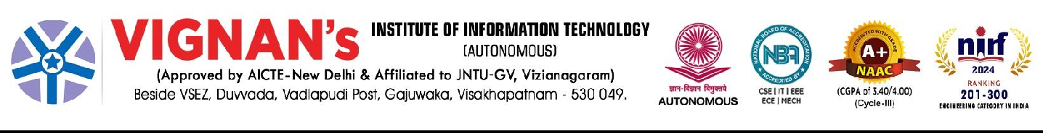

**JNTU-GV Monthly Report Index**

|  |  |  |
| --- | --- | --- |
| **S.NO** | **SUBJECT** | No. of events |
| **1.** | Training & Workshops organized | 04 |
| **2.** | Co-Curricular Activities |  |
| **3.** | Research Publications |  |
| **4.** | Student Support Practices |  |
| **5.** | Creative & Innovative in curriculum, Teaching Learning practices, Student Evaluation, Student Progression etc., |  |
| **6.** | Awards & Recognitions |  |

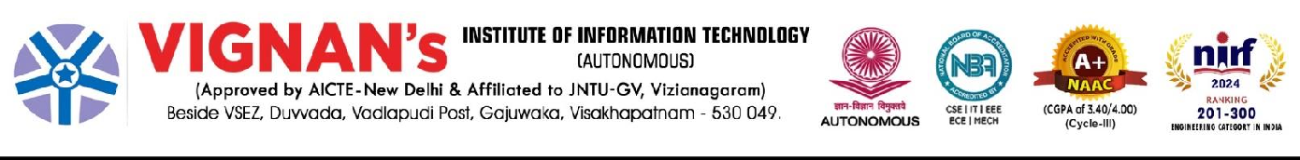

## INSTITUTE MONTHLY REPORT – April 2025

**Event Summary**

1. **Training & Workshops organized**

|  |  |  |
| --- | --- | --- |
| **S.No** | **Particulars** | **Image** |
| **1** | Interactive Session with Industry Expert organized by ECE, EEE and ECM  **Shri. DVR Murthy , Vice President ,** MoS Technologies Limited, Hyderabad |  |
| **2** | Awareness Program on “Self Defense” to all girl students on 11-04-2025,  EEE Dept in association with WEPC  KYOSHI.CH.SRINIVASA. INTERNATIONAL GOLD MEDEL. WINNER. |  |
| **3** | **CIPU’s Bharat Higher Education Summit 2025, organized in association with Mahindra University, Hyderabad.**  Prof. T. G. Sitharam, Chairman, AICTE, has confirmed as the Guest of Honour, and Prof. (Dr.) Anil Sahasrabudhe, Chairman, Executive Committee, NAAC & Chairman, NBA |  |
| **4** | **Guest Lecture on Career Choices on 29-04-2025**  **Organised by: MBA**  Ms. Akshaya Sivakumar Product & Strategy Leader Ex-Ninjacart, Ex-Goldman Sachs IIM Ahemdabad, IIT Madras |  |

1. **Co-Curricular Activities**

**Edu-skills Cohort 10 & 11 status**

Our Institute stood in **Top 3** position in the Cohort 10

|  |  |  |  |
| --- | --- | --- | --- |
|  | **Total no. of Students Registered** | **Total no. of students Completed** | **% of students Completed** |
| **Cohort 10** | **4157** | **2900** | **70%** |
| **Cohort 11** | **2182** | **1410** | **65%** |
| **Cohort 12** | **1477** | **50** | **-** |

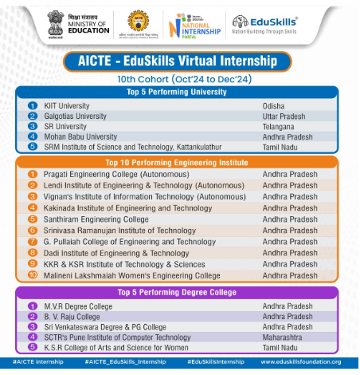

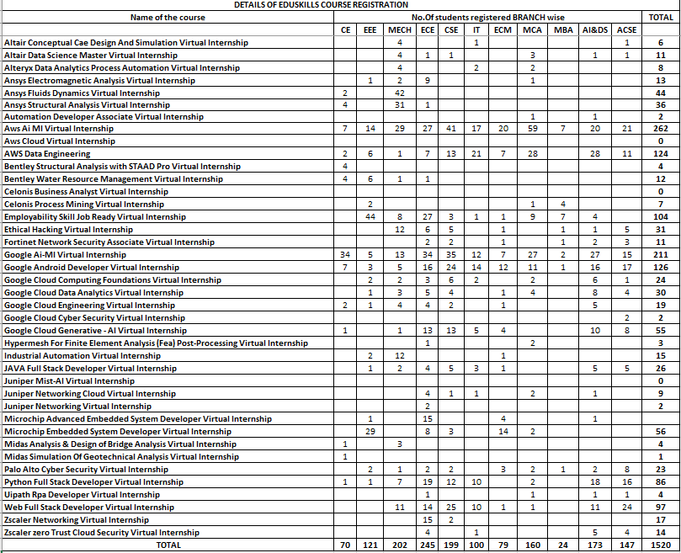



|  |  |  |  |  |
| --- | --- | --- | --- | --- |
| **S. No.** | **Year & Branch** | **Total No. of Students** | **No. of Students Registered** | **%. of Students Registered** |
| **1.** | **II CE** | **117** | **70** | **59.8%** |
| **2.** | **III CE** | **123** | **83** | **67.4%** |
| **3.** | **IV CE** | **155** | **45** | **29** |
| **Total** | |  | **198** |  |

|  |  |  |
| --- | --- | --- |
| **S.No.** | **Name of the course** | **No.Of students registered** |
| **1** | **Altair Conceptual Cae Design And Simulation Virtual Internship** | **2** |
| **2** | **Altair Data Science Master Virtual Internship** |  |
| **3** | **Alteryx Data Analytics Process Automation Virtual Internship** |  |
| **4** | **Analysis & Design Of Bridge Virtual Internship** |  |
| **5** | **Ansys Fluids Dynamics Virtual Internship** | **11** |
| **6** | **Ansys Structural Analysis Virtual Internship** | **2** |
| **7** | **Aws Cloud Virtual Internship** | **28** |
| **8** | **Bentley Structural Analysis with STAAD Pro Virtual Internship** | **117** |
| **9** | **Bentley Water Resource Management Virtual Internship** | **31** |
| **10** | **Employability Skill Job Ready Virtual Internship** | **1** |
| **11** | **Ethical Hacking Virtual Internship** |  |
| **12** | **Fortinet Network Security Associate Virtual Internship** |  |
| **13** | **Google Ai-Ml Virtual Internship** |  |
| **14** | **Industrial Automation Virtual Internship** | **1** |
| **15** | **JAVA Full Stack Developer Virtual Internship** |  |
| **16** | **Juniper Mist-AI Virtual Internship** |  |
| **17** | **Juniper Networking Cloud Virtual Internship** |  |
| **18** | **Juniper Networking Virtual Internship** |  |
| **19** | **Microchip Embedded System Developer Virtual Internship** |  |
| **20** | **Palo Alto Cyber Security Virtual Internship** |  |
| **21** | **Python Full Stack Developer Virtual Internship** |  |
| **22** | **Simulation of Geotechnical Analysis Virtual Internship** |  |
| **23** | **Zscaler Networking Virtual Internship** |  |
| **24** | **Zscaler zero Trust Cloud Security Virtual Internship** |  |
| **25** | **AWS Data Engineering** | **3** |
| **26** | **Midas Simulation Of Geotechnical Analysis Virtual Internship** | **1** |
|  | **TOTAL** | **198** |

|  |  |  |
| --- | --- | --- |
| **.No** | **Particulars** | **Image** |
| **1** | Interactive Session by Shri. DVR Murthy, Vice President, MoSchip Technologies Limited. On 04-04-2025  Event Coordinator : Mrs. A. Sarvani  No. of students participated : 60  No. of staff participated : 05 |  |
| **2** | **Extra Curricular Activities**:  Name of the activities: Health Camp for Girl Students from 07-04-2025 to 09-04-2025  Event Coordinator : Mrs. A. Sarvani  No. of students participated:44  No. of staff participated:04 |  |

1. **Research Publications:**

|  |  |
| --- | --- |
| **Faculty Details: 17** | |
| **Professors** | **0** |
| **Associate Professors** | **6** |
| **Assistant Professors** | **11** |
| **No. of doctorates** | **6** |
| **Ph.D pursuing** | **6** |
| **Ph.D Thesis submitted** | **2** |

**Publications:**

|  |  |  |  |
| --- | --- | --- | --- |
| **Published** | **Accepted** | **Communicated** | **Total** |
| **2** | **1** | **10** | **13** |

**Patents:**

|  |  |  |  |
| --- | --- | --- | --- |
| **Year** | **Patent Title** | **Agency** | **Status** |
| **2024** | **--** |  | **0** |
| **2024** | **--** |  | **0** |
| **2024** | **--** |  | **0** |

**The faculty members have published research articles in SCIE journals during April 2025.**

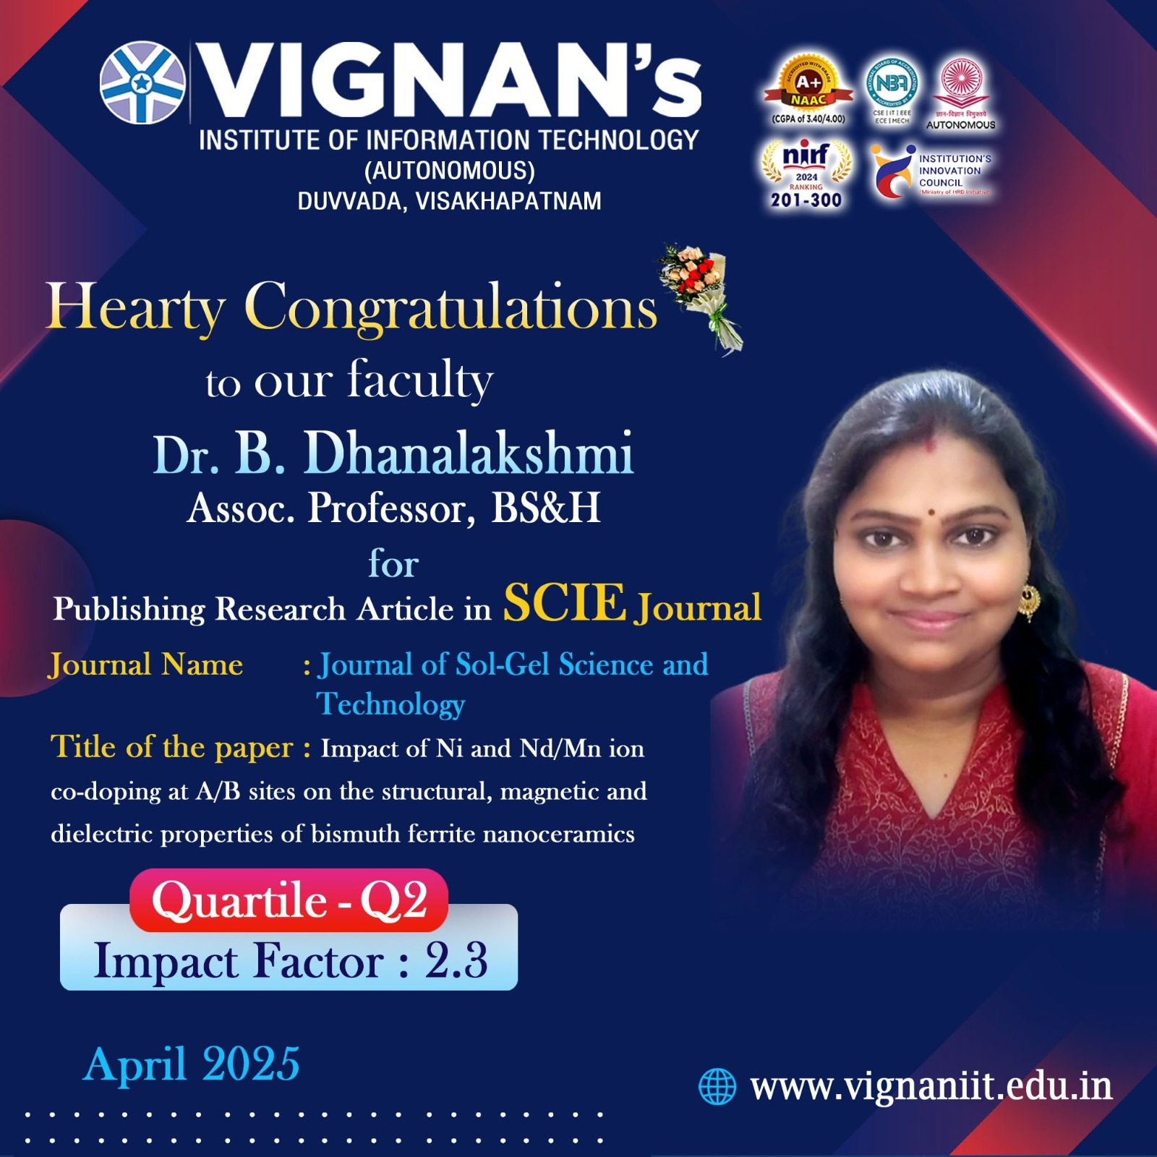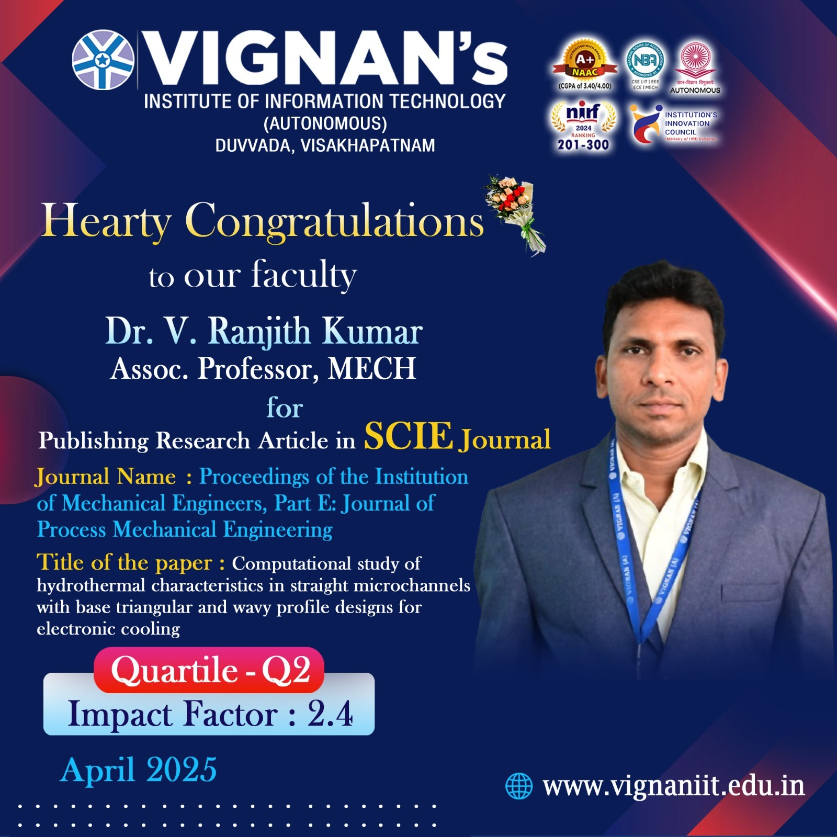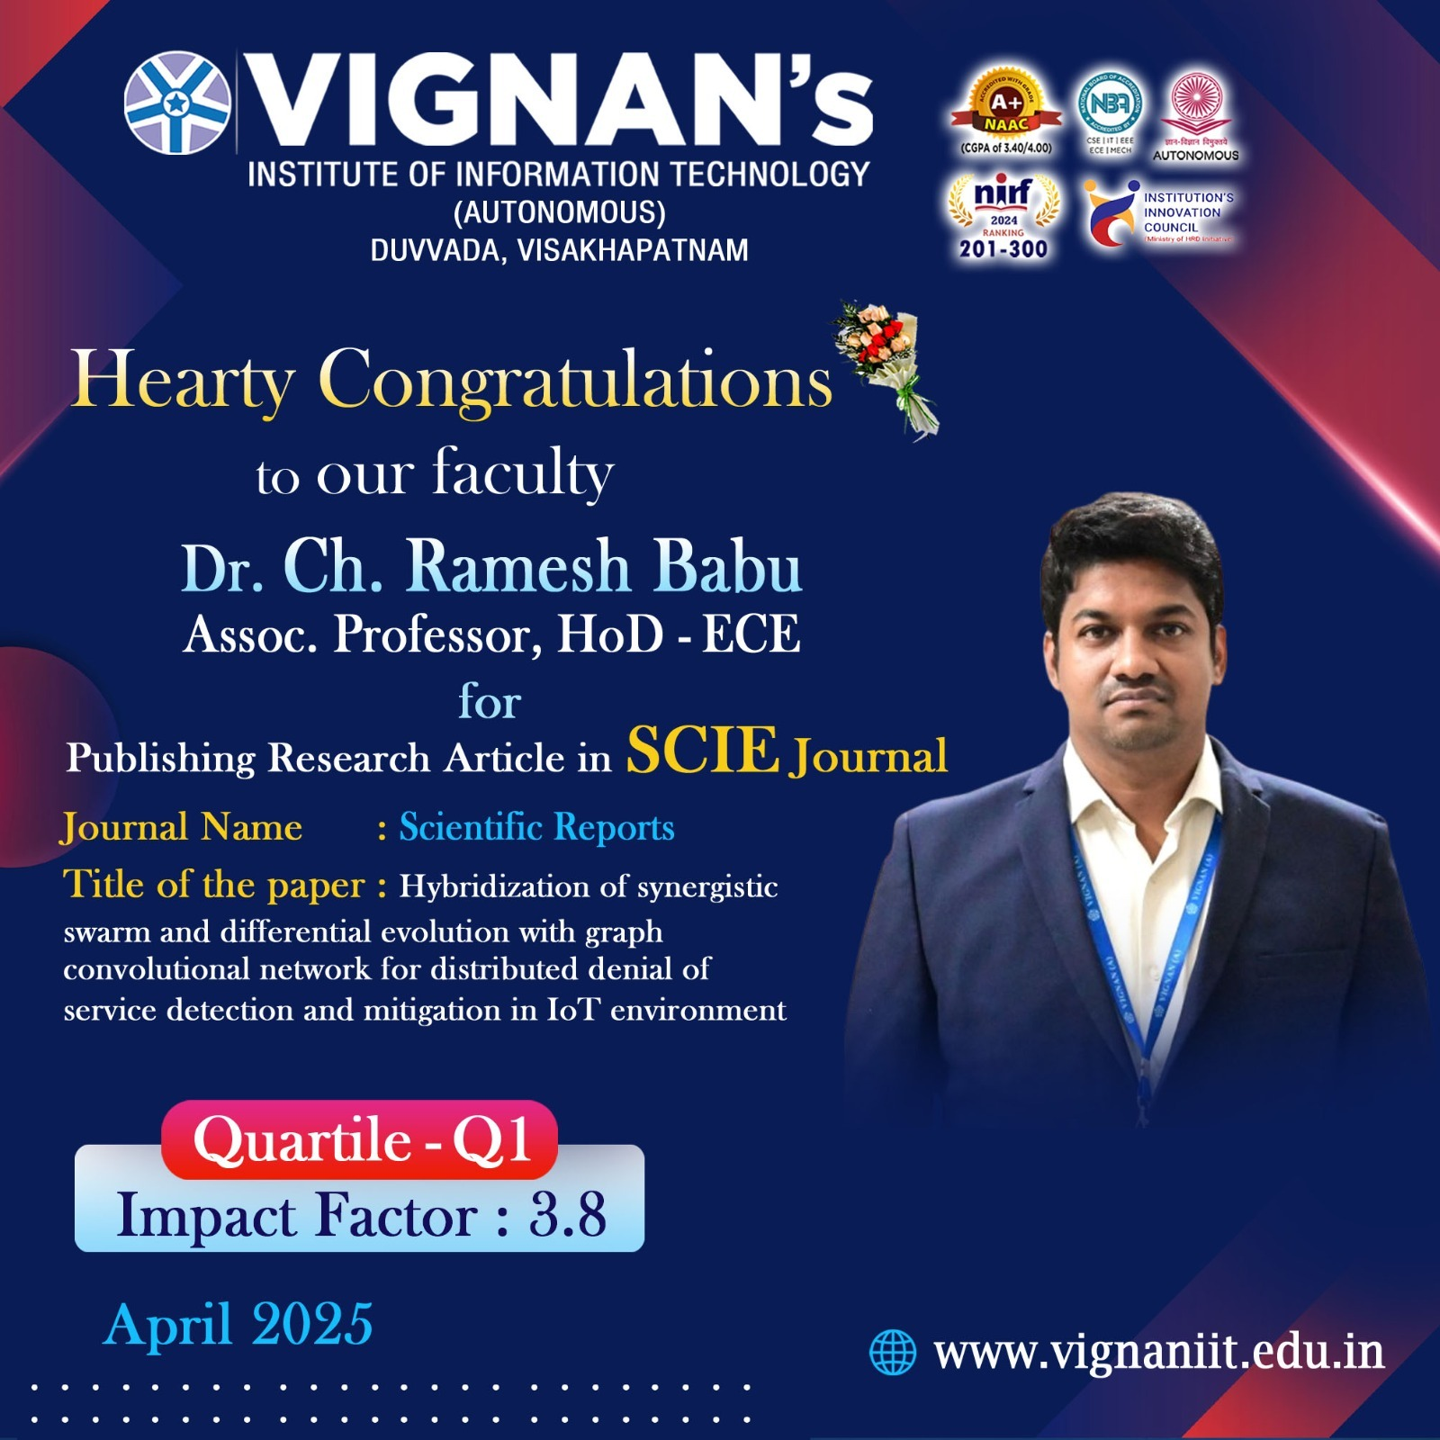

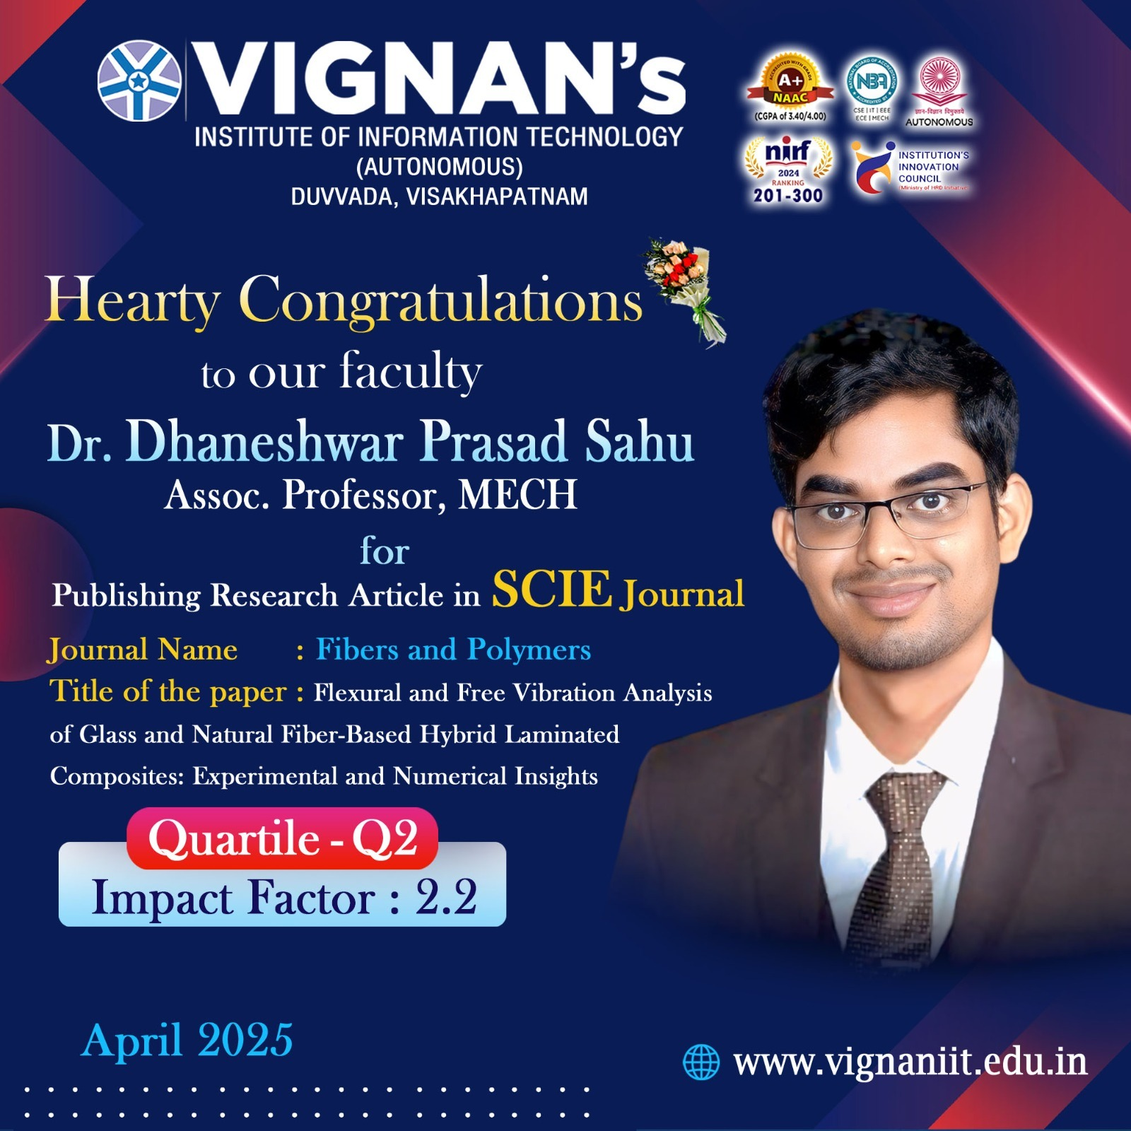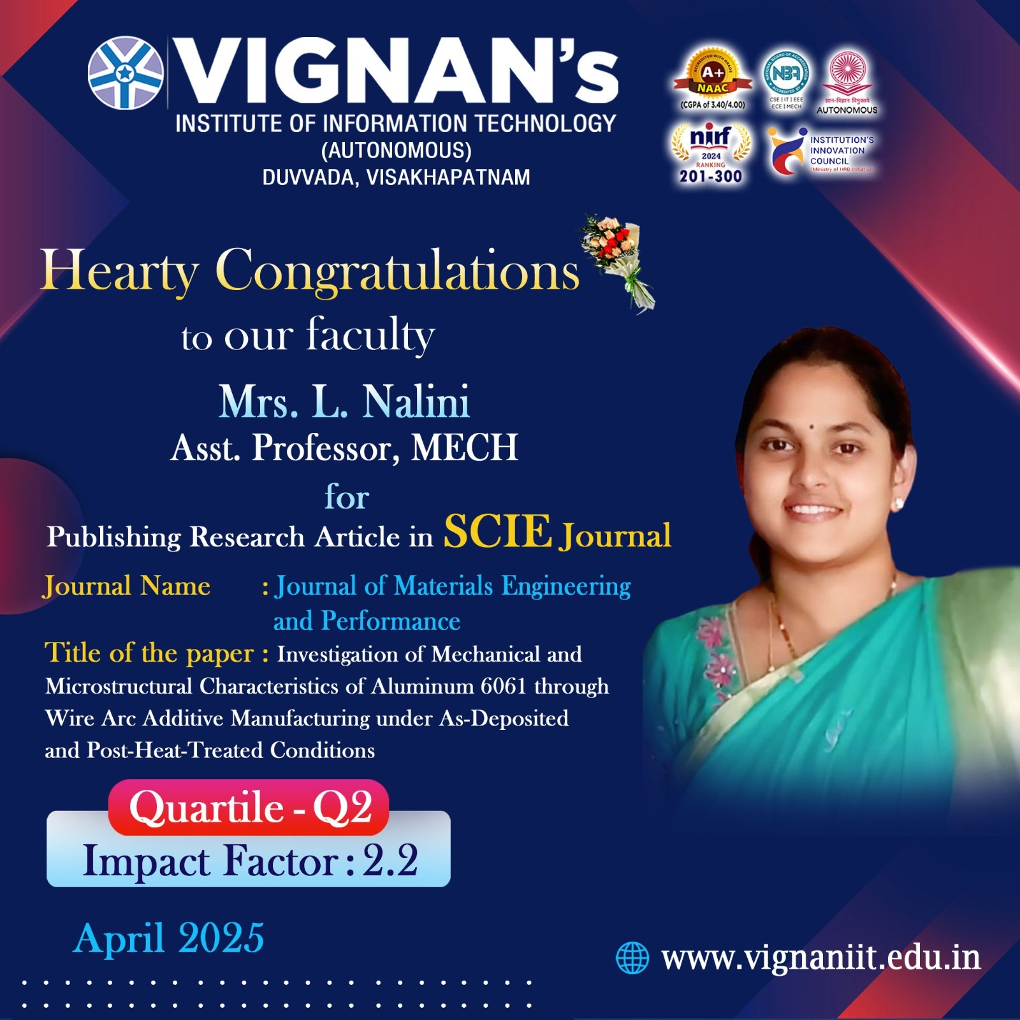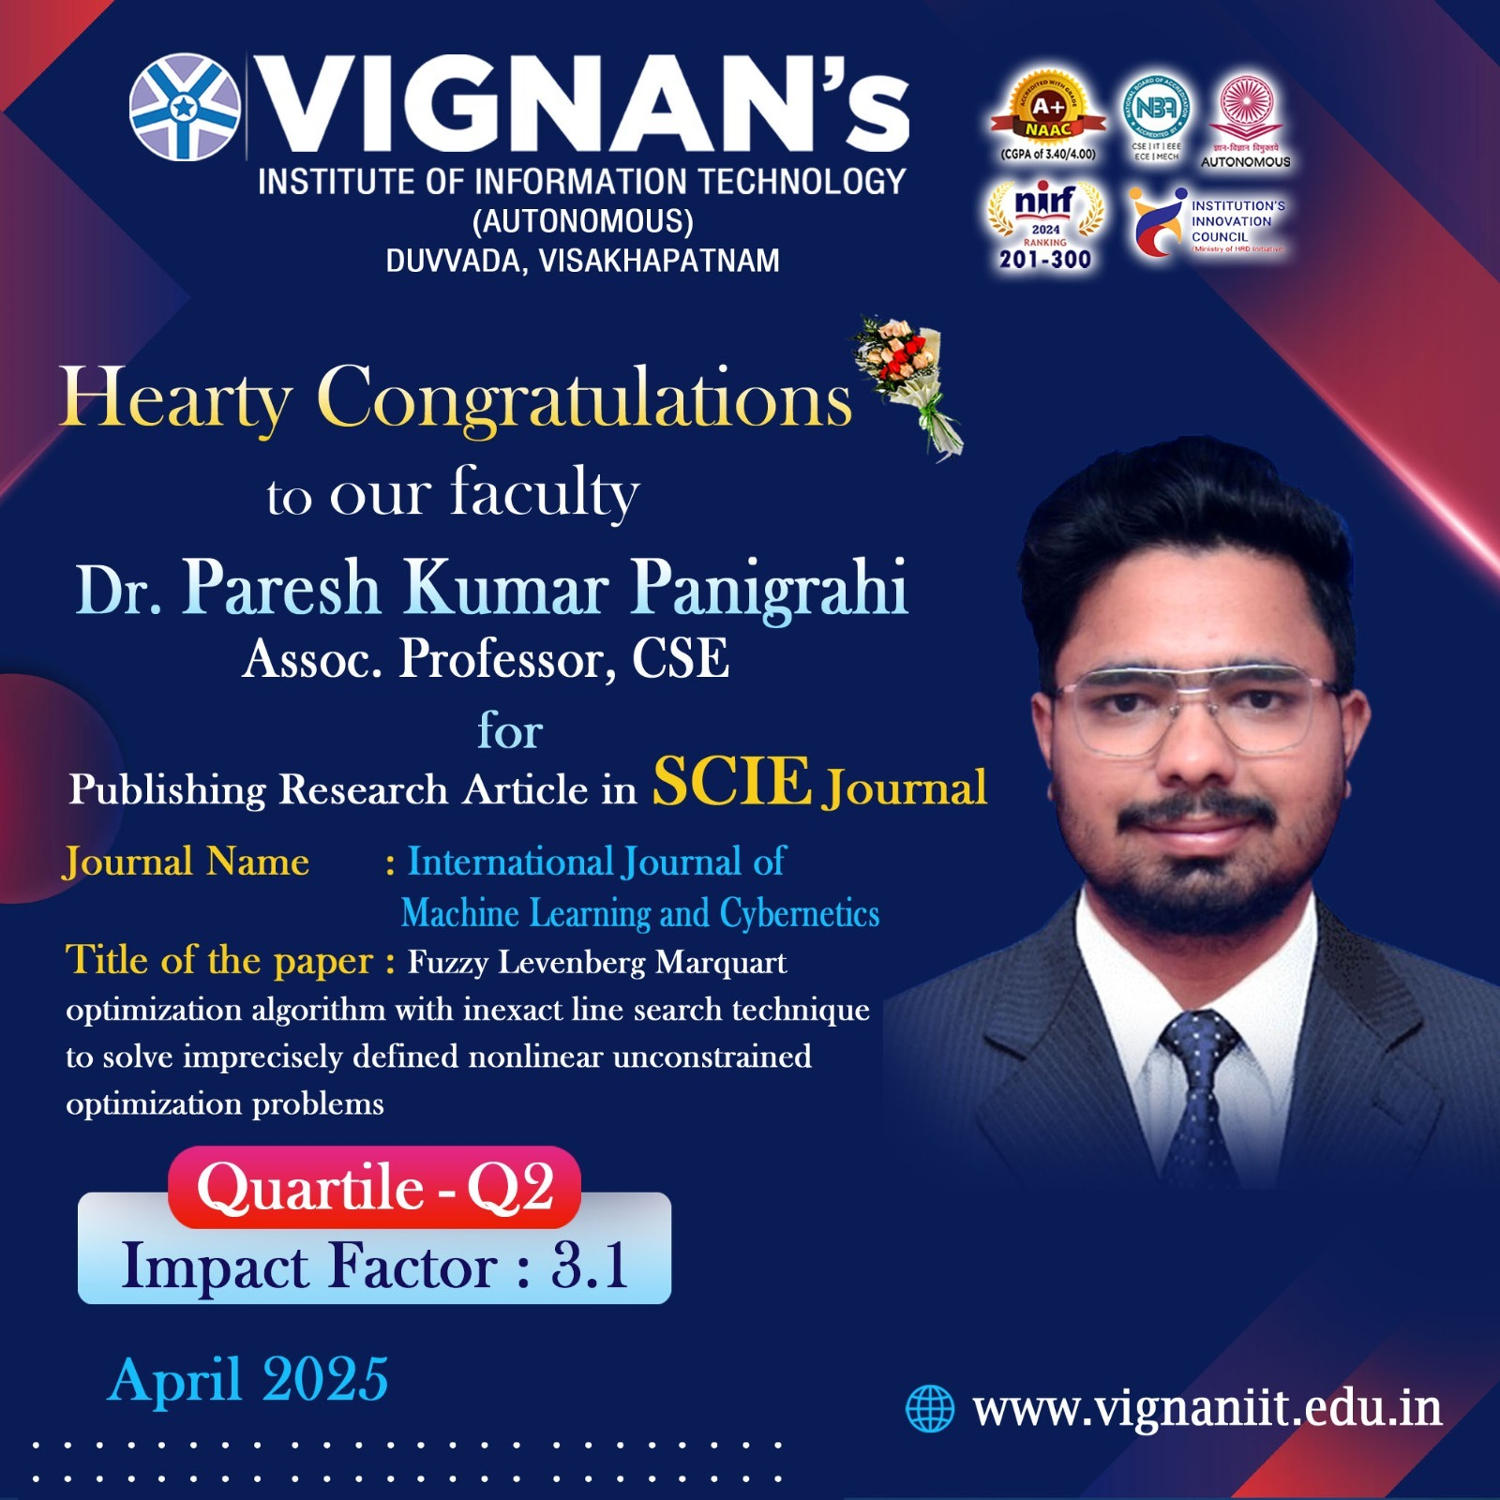

**Status of Faculty Publications and Research**

|  |  |  |  |  |  |  |
| --- | --- | --- | --- | --- | --- | --- |
| **S. No** | **Faculty Name** | **Designation** | **Published** | **Accepted** | **Communicated** | **Total** |
| **1** | **Dr.L.GOVINDA** | **Assoc. Professor** | **1(SCIE-Q2)** | **-** | **2** | **3** |
| **2** | **Dr.G.T.L.PRIYANKA** | **Assoc. Professor** | **-** | **-** | **-** | **-** |
| **3** | **Dr.G.AMULYA** | **Assoc.Professor** | **-** | **-** | **1** | **1** |
| **4** | **Dr.S.GAYATHRI** | **Assoc.Professor** | **-** | **-** | **-** | **-** |
| **5** | **Dr.A.SRIJA** | **Assoc.Professor** | **-** | **-** | **-** | **-** |
| **6** | **Mr.M.PADMAKAR** | **Asst.Prof & HOD** |  |  | **2** | **2** |
| **7** | **Mr.K.SRINIVAS** | **Asst.Prof & Asst.HOD** | **-** | **-** | **2** | **2** |
| **8** | **Mr.B.BRAMAIAH** | **Assistant Professor** |  |  |  | **-** |
| **9** | **Mrs.KRANTHI VIJAYA** | **Assistant Professor** |  |  |  |  |
| **10** | **Mr.ROHITH BABU** | **Assistant Professor** | **-** | **-** | **1** | **1** |
| **11** | **Ms.M.YOGA SWARNA** | **Assistant Professor** | **-** | **-** | **-** | **-** |
| **12** | **Mr.M.BABU RAO** | **Assistant Professor** | **-** | **-** | **-** | **-** |
| **13** | **Mr.A.TEJA** | **Assistant.Professor** | **-** | **-** | **-** | **-** |
| **14** | Ms.K.SREE SANDHYA | Assistant.Professor | **-** | **-** | **1** | **1** |
| **15** | Mrs.P.M.L.MOUNIKA | Assistant Professor | - | - | - | - |
| **16** | Mr.B.ASHOK KUMAR REDDY | Assistant Professor | - | - | - | - |
| **17** | Mr.G.ARAVIND | Assistant Professor | 1 (Scopus) | - | - | 1 |
| **18** | Mr.D.SREEMAN | Assistant Professor | - | - | - | - |

1. **Student Support Practices:**

|  |  |  |  |  |  |  |  |  |
| --- | --- | --- | --- | --- | --- | --- | --- | --- |
| **Year** | | **No. of certification courses by Student** | | | | | **Students**  **Awards/Prizes** | |
| **NPTEL/ Swayam Plus (Registered)** | **EduSkills** | **Industry Certifications** | | **CISCO** | **In Co-Curricular activities** | **In extra Curricular activities** |
| **II Year** | | **18/48** | **59** | **-** | | **65** | **01** | **-** |
| **III Year** | | **08/55** | **40** | **-** | | **55** | **03** | **-** |
| **IV Year** | | **-** | **-** | **-** | | **-** | **01** | **-** |
| **Total** | | **26/103** | **99** | **-** | | **120** | **05** | **-** |
| **.No** | **Particulars** | | | | **Image** | | | |
| **1** | Project Expo & St.Anns Students Visited ECE Department. On 04-04-2025 | | | |  | | | |
| **2** | On the occasion of World Health Day, SAC in association with WEPC has planned to organize "ONE WEEK HEALTH CAMP" for all lady staff and girl students of all departments from 07/04/2025 to 12/04/2025. | | | |  | | | |
| **3** | Event: Essay writing Competition on the occasion of Dr.BR. Ambedkar Birthday on 11.05.2025  Event Organizers: SAC  Event coordinator:  Dean Student Affairs -Mr. Shivaramakrishna  Faculty coordinators:  Mrs.V.Savitri,  Mrs.D.Pratushya  Mrs.M.Himabindu | | | |  | | | |
| **4** | International Youth Festival two days event conducted for international Students from 16-04-2025 to 17-04-2025  Organized by International-SAC | | | |  | | | |
| **5** | I B.Tech. Parent - Teacher Interaction on 26.04.2025 | | | |  | | | |
| **6** | Name of the Event :  INTERNATIONAL DANCE DAY ON 29-04-2025  Organised by: SAC | | | |  | | | |

**5(a) Creative & Innovative in curriculum. Teaching Learning practices, Student Evaluation, Student Progression etc.,**

|  |  |  |  |
| --- | --- | --- | --- |
| **S.No** | **Particulars** | **Image** | |
| **1** | Interactive session with industry expert    Date: 04-04-2025  Participants: II ECM  Resource Persons: Shri. DVR Murthy, Vice President, MosChip Technologies, Hyderabad.  Objective:  An Interactive session is a great opportunity to learn and gain the knowledge on Industry gaps. The workshop allows you to explore real-world scenarios and fill the gaps between Industry and academia. It’s an excellent way to enhance the skill and stay ahead in the competitive job market. | |  |

**5(a) Report on Utilization of Faculty development (Professional body membership fee/attend conferences/workshops)**

1. **Awards & Recognitions**

**PRINCIPAL**